**Project Design Phase-II**

**Data Flow Diagram & User Stories**

|  |  |
| --- | --- |
| Date | 26-05-2025 |
| Team ID | LTVIP2025TMID61039 |
| Project Name | Rental Home:Finding Your Perfect Home |
| Maximum Marks | 4 Marks |

**Data Flow Diagrams:**

Level 0 (Context Diagram)

Shows the system as a single process with external entities.

Entities:

Tenant → searches, books, pays rent.

Landlord → lists properties, manages bookings.

Admin → verifies users/properties, monitors platform.

Payment Gateway → processes payments securely.

Level 1 (Detailed DFD)

Breaks the system into sub-processes:

1. User Management → Register, login, manage profile.

2. Property Management → Add/update listings, photos, availability.

3. Search & Booking → Tenants search/filter, request visits, book rentals.

4. Payment Processing → Rent/deposit payment, receipts.

5. Notifications & Communication → Alerts, chat between tenant & landlord.

6. Admin Control → Verification, fraud detection, reporting.

---

🗂 DFD Description in Table Format

|  |  |  |  |
| --- | --- | --- | --- |
| **Process** | **Input** | **Output** | **Data Store** |
| **User Management** | Tenant/Landlord registration, login credentials | Authenticated user sessions, profiles | User Database |
| **Property Management** | Landlord property details, photos, availability | Verified property listings | Property Database |
| **Search & Booking** | Tenant search filters, booking requests | List of matching properties, booking status | Search Index, Booking Records |
| **Payment Processing** | Tenant rent/deposit payment info | Payment confirmation, receipts | Payment Transactions DB, Payment Gateway |
| **Notifications & Communication** | Booking status, chat messages, rent reminders | Push notifications, emails, chat updates | Notification Service, Message Store |
| **Admin Control** | User/property verification data, reports request | Verified accounts, fraud alerts, analytics | Admin Dashboard, Reports Database |

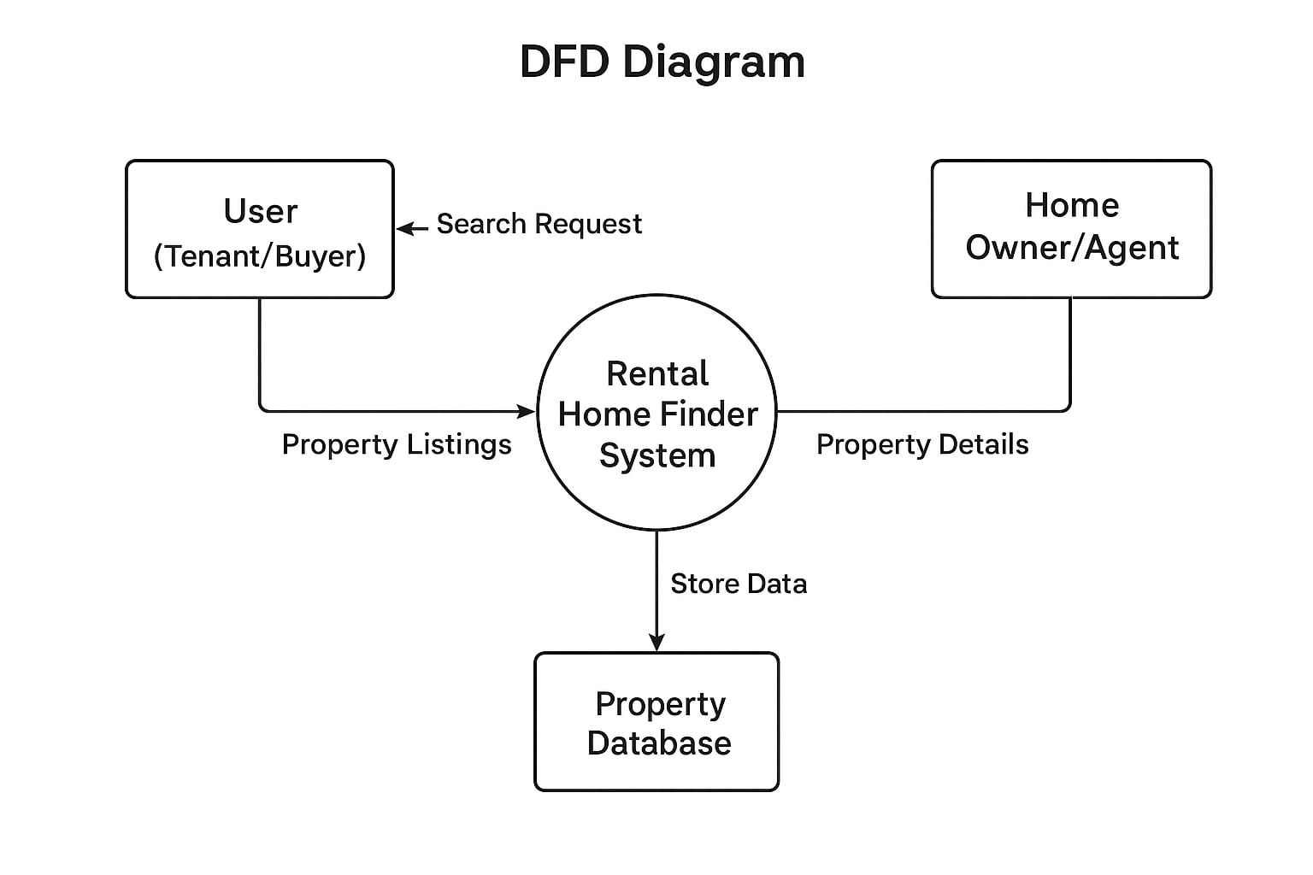

**User Stories**

**User Story Table – Rental House Finding**

|  |  |  |  |
| --- | --- | --- | --- |
| **User Role** | **User Story** | **Acceptance Criteria** | **Priority** |
| **Tenant / Buyer** | **As a tenant, I want to search for rental houses by location, price, and size so that I can find suitable homes easily.** | **- Able to filter houses by city/area, budget, number of rooms.  - Search results load quickly.** | **High** |
| **Tenant / Buyer** | **As a tenant, I want to view detailed property information so that I can evaluate if it matches my needs.** | **- Property page shows images, price, amenities, location map, and owner contact details.** | **High** |
| **Tenant / Buyer** | **As a tenant, I want to save favorite listings so that I can compare them later.** | **- A “Save” button is available on each property.  - Saved properties are stored in user profile.** | **Medium** |
| **Home Owner / Agent** | **As an owner, I want to list my rental property so that tenants can see it.** | **- Form to upload property details (price, size, location, images).  - Property gets stored in system.** | **High** |
| **Home Owner / Agent** | **As an owner, I want to manage (edit/update) my property listings so that I can keep information accurate.** | **- Owners can update details (price, availability).  - Changes are reflected in real-time.** | **Medium** |
| **System Admin** | **As an admin, I want to manage user accounts so that the platform remains secure.** | **- Admin can block/report suspicious accounts.  - Admin can view all listings and users.** | **Low** |
| **System (Auto)** | **As the system, I want to send notifications when a tenant saves or inquires about a property so that owners can respond quickly.** | **- Notifications via email/app alert.  - Triggered instantly when action occurs.** | **Medium** |